TANGEDCO will cut down losses by Rs 1,000 cr a year: CMD Lakhoni
G Balachandar | Chennai, February 8 | Updated on: Feb 08, 2022
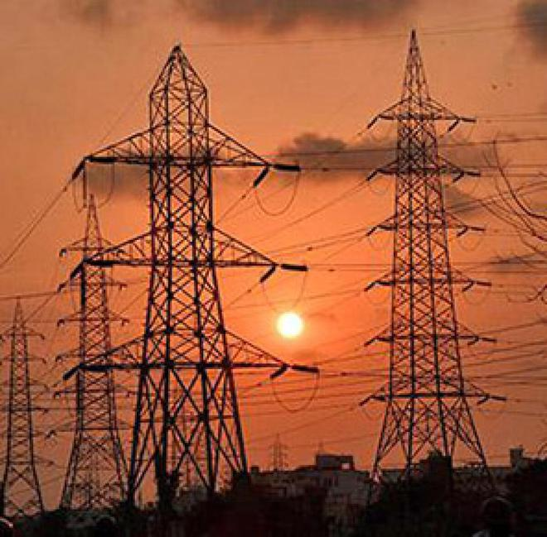

Also in talks with pit-head coal-based plants for procuring power at a cheaper cost
Tamil Nadu state’s power generating and distributing utility TANGEDCO (Tamil Nadu Generation and Distribution Corporation Ltd) has undertaken several measures to cut the losses by about ₹ 1,000 crore a year, said Rajesh Lakhoni, Chairman & Managing Director of TANGEDCO. In 2020-21, the power utility incurred a loss of ₹32,553 crore.
“Earlier, our losses were increasing at the rate of ₹1,500-2,000 crore per annum. However, from this year the losses will be reduced by ₹1,000 crore. Without even increasing the tariff, there is about ₹3,000 crore of benefits by improving operational efficiency, optimising the use of various coal sources. Also, optimising the use of high-cost power (vs our own power) and some cost-cutting measures also helped,” he said while virtually addressing a conference on Tamil Nadu Energy – the way to a sustainable future – organised by the Madras Chamber of Commerce & Industry (MCCI).

How India defies gravity in global equity sell-off
He was trying to drive home the point that TANGEDCO was moving in a positive direction in many areas in order to ensure stability. “Let me assure you that people don’t have to worry about energy availability in the State. TANGEDCO is preparing to meet the emerging energy demand and it has already planned 5,600 MW of power plants that are under construction and will come up over 2-3 years,” he added.

Focus on solar power
TANGEDCO is also talking to some of the pit-head coal-based plants for procuring power at a cheaper cost. “Apart from that, we have a stronger focus on the solar power segment. Tamil Nadu has also allowed the highest number of open access to people and the State is hand-holding private people and letting them grow,” said Lakhoni.
He also pointed out that the spinning mill cluster has grown in Tamil Nadu because of the State’s banking policy and wind power availability. Since energy costs for spinning mills are 55-60 per cent, the banking system has really helped bring down the energy costs significantly.
“Our policies have always been sustainable and we are aware of the needs of the industry. Now, we are working on many innovative things in the solar segment,” he said.
Srivats Ram, President, MCCI pointed out that Tamil Nadu should hold on to its title of having a fairly large renewable mix in power generation. And it’s also important to ensure that the State is able to meet its export customers’ requirements and also align with the Prime Minister’s vision for the country moving forward, Ram said.
“Export customers are asking for visibility towards having 100 per cent sustainable power for people who are supplying it to them. This is a challenge. And lastly, we also need sustainability of the power source in Tamil Nadu to be there. Not just environmental sustainability but also financial sustainability. It needs to be a win-win situation for all, he added.

